**PATUAKHALI SCIENCE AND TECHNOLOGY UNIVERSITY**

Course Code: C

IT

-

11

2



**SUBMITTED TO:**

Prof. MD Mahbubur Rahman Sir

**Department of Computer Science And Communication**

**Engineering**

**Faculty of Computer Science And Engineering**

**SUBMITTED BY:**

Name: MD Noushad Bhuiyan

ID: 2102038, Registration No: 10165

Faculty of Computer Science and Engineering

**Date of submission: 22-4-2023**

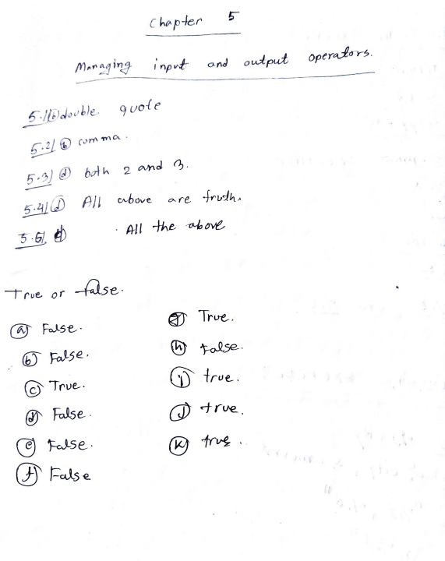

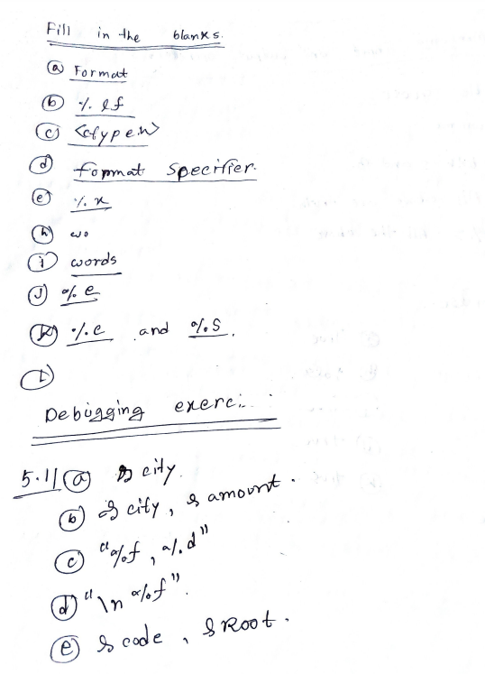

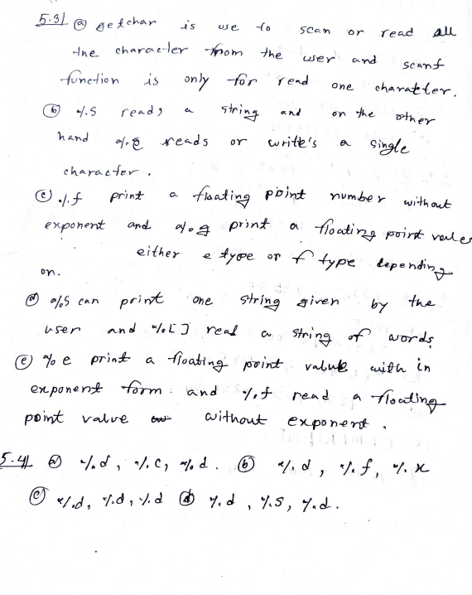

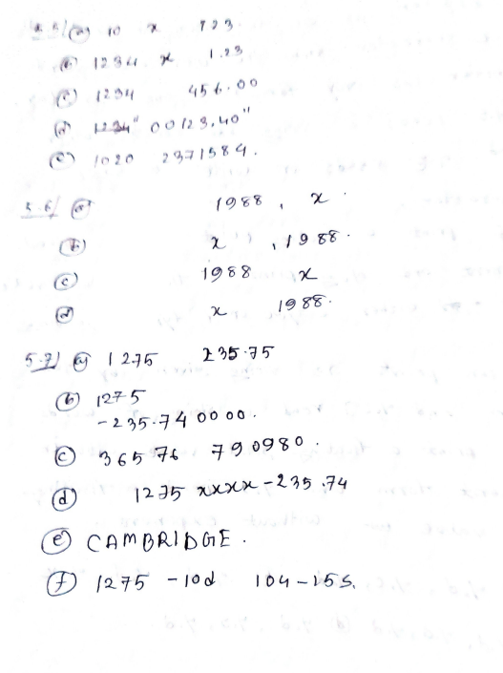

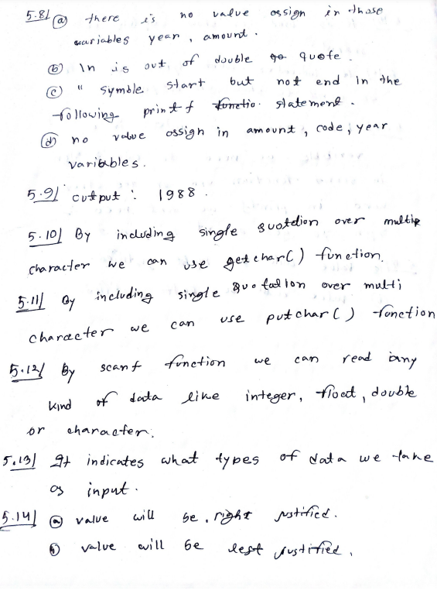

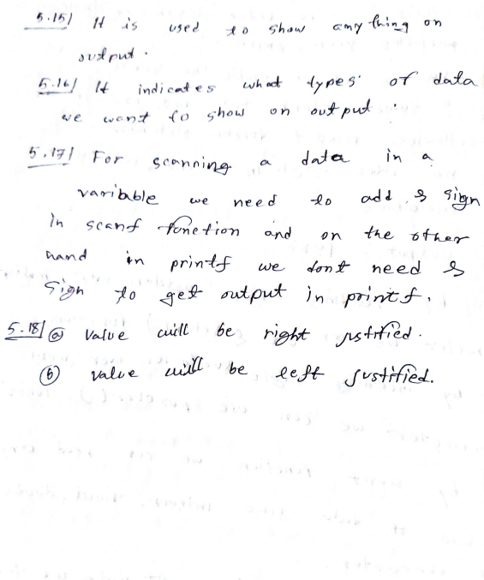

**Chapter 5**

**5.1 Given the string “WORDPROCESSING”, write a program to read the string from the terminal and display the same in the following formats: (a) WORD PROCESSING (b) WORD PROCESSING (c) W.P**

#include<stdio.h>

int main()

{

char x[100]={"WORD"};

char y[100]={"PROCESSING"};

printf("(a) %4s %10s\n",x,y);

printf("(b) %s\n%s\n",x,y);

printf("(c) %.1s.%.1s.\n",x,y);

}

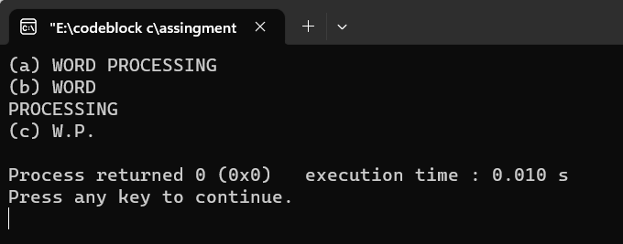

**5.2 Write a program to read the values of x and y and print the results of the following expressions in one line: (a) (x+y)/(x–y) (b) (x+y)/2 (c) (x+y)(x–y)**

#include<stdio.h>

int main()

{

float a,b,c,x,y;

printf("Enter x and y: ");

scanf("%f %f",&x,&y);

a=(x+y)/(x-y);

b=(x+y)/(x);

c=(x+y)*(x-y);

printf("a = %0.2f ",a);

printf("b = %0.2f ",b);

printf("c = %0.2f ",c);

}

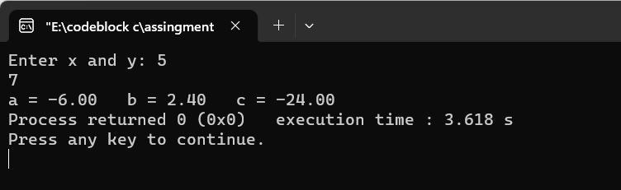

**5.3 Write a program to read the following numbers, round them off to the nearest integers and print out the results in integer form: 35.7 50.21 – 23.73 – 46.45**

#include<stdio.h>

int main()

{

int a=35.7+.5;

int b=50.21+.5;

int c=-(23.73+.5);

int d=-(46.45+.5);

printf("a = %d , b = %d , c = %d , d = %d",a,b,c,d);

}

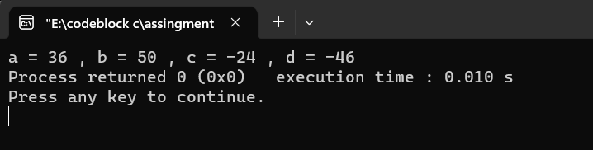

**5.4 Write a program which print n number of raw and n number of columb with * symbol**

#include<stdio.h>

int main()

{

int i,j,n;

printf("Enter n: ");

scanf("%d",&n);

for(i=1;i<=n;i++)

{

for(j=1;j<=4;j++)

{printf("* ");

}

printf("\n");

}

}

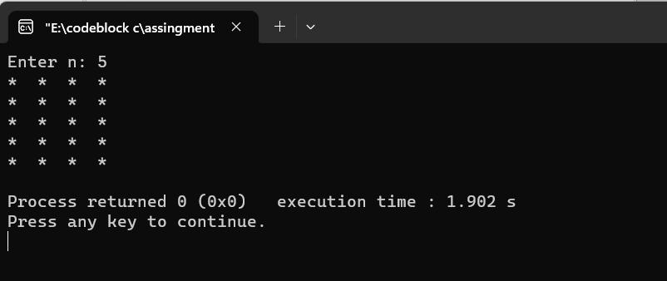

**5.5 Write an interactive program to demonstrate the process of multiplication. The program should ask the user to enter two two-digit integers and print the product of integers**

#include<stdio.h>

int main()

{

int n,x;

printf("Enter two digits multiplicand: ");

scanf("%d",&n);

printf("Enter two digits multiplicator: ");

scanf("%d",&x);

int x1=x%10;

int x2=x/10;

int mul=n*x;

printf(" %d\n",n);

printf(" * %d\n",x);

printf(" ________\n");

printf(" %d* %d is %d\n",x1,n,x1*n);

printf(" %d* %d is %d\n",x2,n,x2*n*10);

printf(" ________\n");

printf(" %d\n",mul);

}

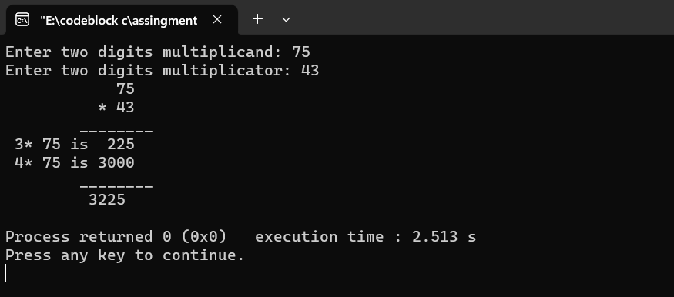

**5.6 Write a program to read three integers from the keyboard using one scanf statement and output them on one line using: (a) three printf statements, (b) only one printf with conversion specifiers, and (c) only one printf without conversion specifiers.**

#include<stdio.h>

int main()

{

int a,b,c;

printf("Enter a,b,c: ");

scanf("%d %d %d",&a,&b,&c);

printf("%d ",a);

printf("%d ",b);

printf("%d \n",c);

printf("%d %d %d\n",a,b,c);

printf("10 20 30\n");

}

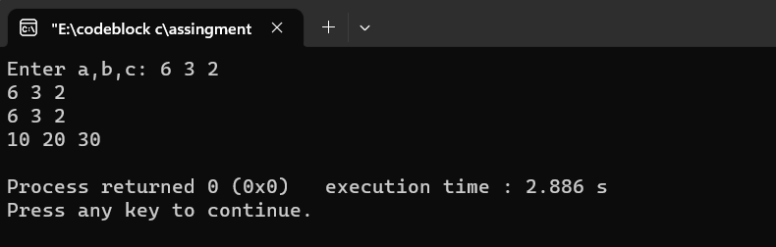

**5.7 Write a program that prints the value 10.45678 in exponential format with the following specifications: (a) correct to two decimal places; (b) correct to four decimal places; and (c) correct to eight decimal places.**

#include<stdio.h>

int main()

{

double x;

x=exp(10.45678);

printf("%0.2lf\n",x);

printf("%0.4lf\n",x);

printf("%0.8lf\n",x);

}

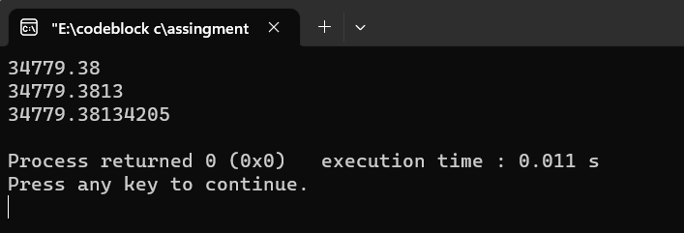

**5.8 Write a program to print the value 345.6789 in fixed-point format with the following specifications: (a) correct to two decimal places; (b) correct to five decimal places; and (c) correct to zero decimal places.**

#include<stdio.h>

int main()

{

double x=345.6789;

printf("%0.2f\n",x);

printf("%0.5f\n",x);

printf("%0.0f\n",x);

}

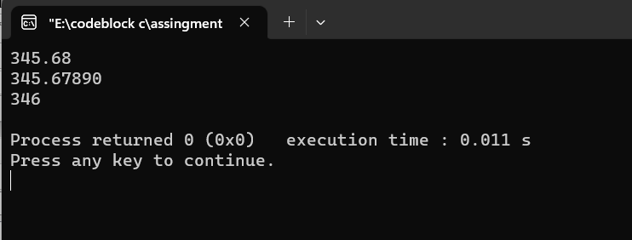

**5.9 Write a program to read the name ANIL KUMAR GUPTA in three parts using the scanf statement and to display the same in the following format using the printf statement. 5.3, 5.4 H] (a) ANIL K. GUPTA (b) A.K. GUPTA (c) GUPTA A.K.**

#include<stdio.h>

int main()

{

char x[100]={"ANIL"},y[100]={"KUMAR"},z[100]={"GUPTA"};

printf("%s %.1s. %s\n",x,y,z);

printf("%0.1s.%0.1s. %s\n",x,y,z);

printf("%s %0.1s.%0.1s. ",z,x,y);

}

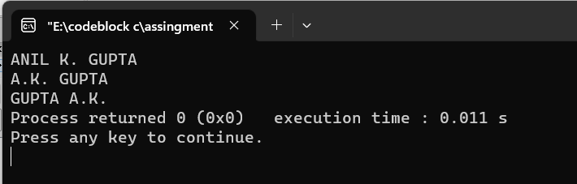

**5.10 Write a program with name code and price information:**

#include<stdio.h>

int main()

{

printf("Name code Price\n");

printf("fan 67831 1234.50\n");

printf("Motor 450 5786.70\n");

}

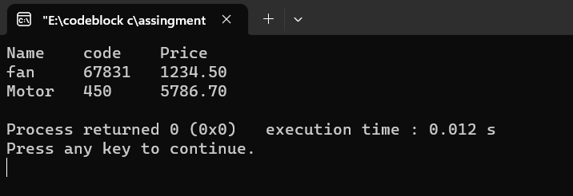

**5.11 Problem**

**5.12 Problem**

**5.13 Write a C program to input a currency value in Dollars and display its equivalent Euro and INR amounts. You may use current exchange rate for conversion purpose.**

#include<stdio.h>

int main()

{

float euro,inr,dollars;

printf("Enter your money in dollar: ");

scanf("%f",&dollars);

euro=dollars*0.92;

inr=dollars*82.18;

printf("The euro value of the money is: %0.2f\n",euro);

printf("The INR value of the money is: %0.2f",inr);

}

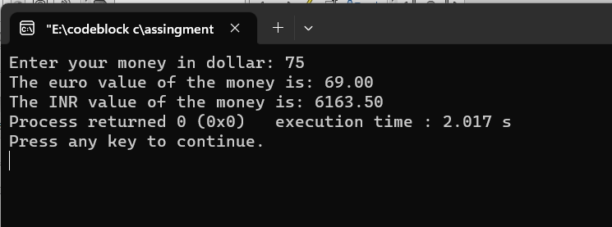

**5.14 Write a C program to display a pattern where 1st line will be 1 2 3 …. n than second line will be 1 2 3 …. (n-1) and go on and at last the line will be 1:**

#include<stdio.h>

int main()

{

int n,r,c;

printf("Enter row number: ");

scanf("%d",&n);

for(r=n;r>=1;r--)

{

for(c=1;c<=n-r;c++)

{

printf(" ");

}

for(c=1;c<=r;c++)

{

printf("%d ",c);

}

printf("\n");

}

}

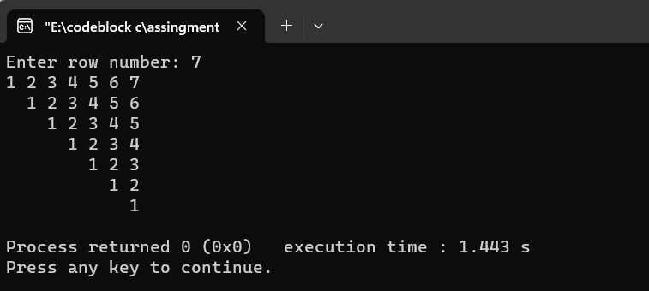

**5.15 Write a C program to input an investment amount and compute its fixed deposit cumulative return after 10 years at a rate of interest of 8.75%.**

#include<stdio.h>

int main()

{

float r=(8.75/100),p,n=10,i,c;

printf("Enter your Investment amount: ");

scanf("%f",&p);

i=p*n*r;

//c=fixed deposit cumulative;

c=i+p;

printf("fixed deposit cumulative is: %0.2f",c);

}

